Terraform Final Task
1)Create VPC
Created an AWS VPC with CIDR block 10.0.0.0/16 using Terraform.
Terraform code for VPC creation in main.tf.
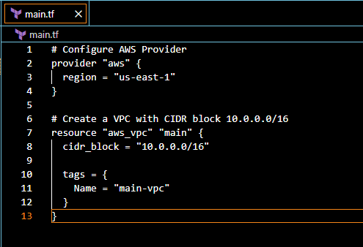
Commands executed terraform init, terraform validate, terraform plan, terraform apply

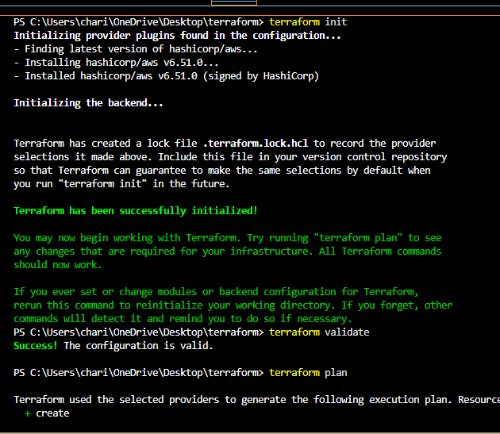
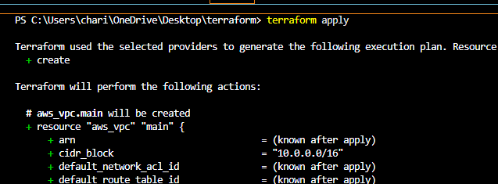
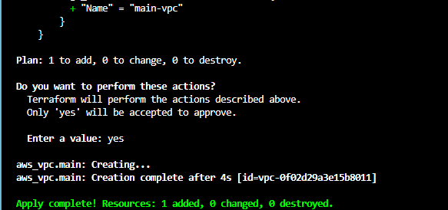
The VPC named main-vpc was successfully created with the CIDR block 10.0.0.0/16.
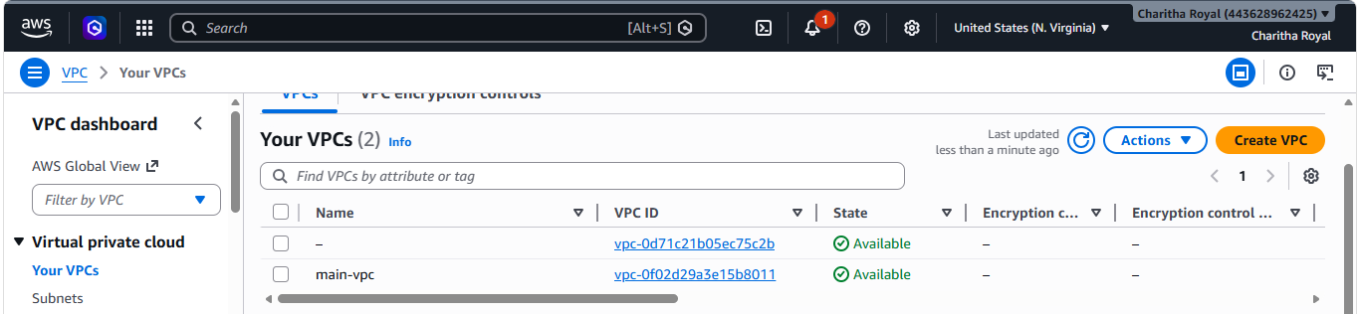
2) Create Internet gateway
Internet Gateway creation using Terraform.
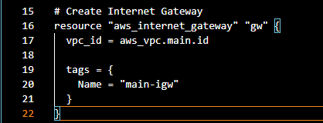
Commands executed terraform fmt, terraform validate, terraform plan, terraform apply

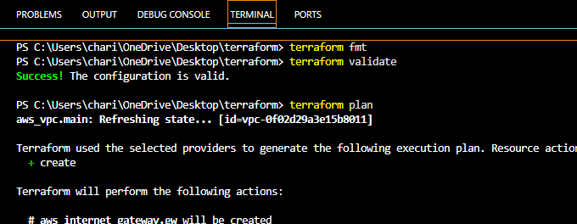
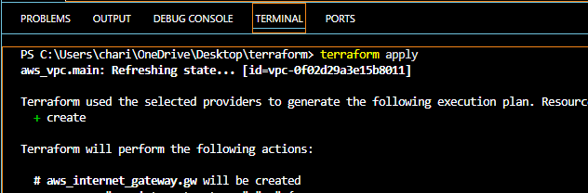
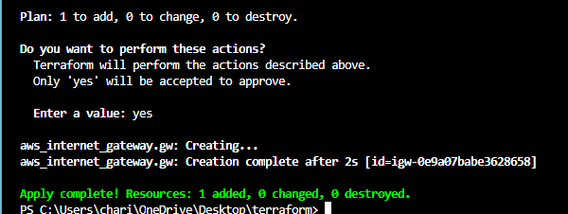
The IGW named main-igw was successfully created
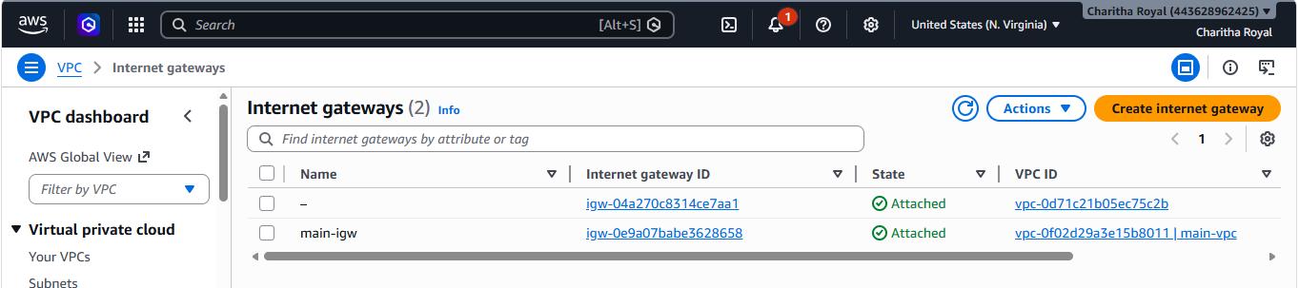
3) Create Custom Route Table
Custom Route Table creation using Terraform.
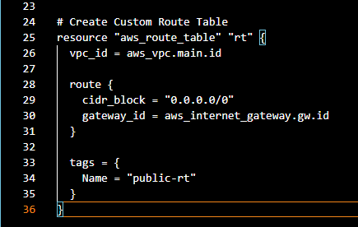
Commands executed terraform fmt, terraform validate, terraform plan, terraform apply
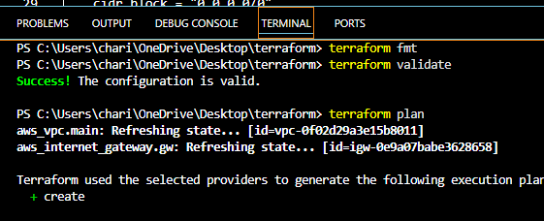
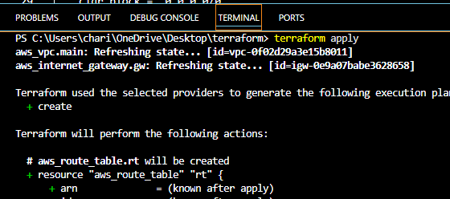
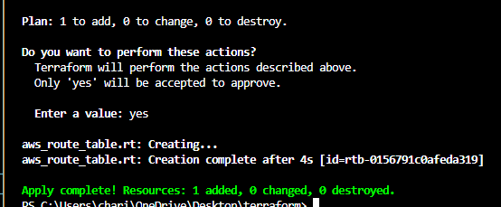
The RT named public-rt was successfully created
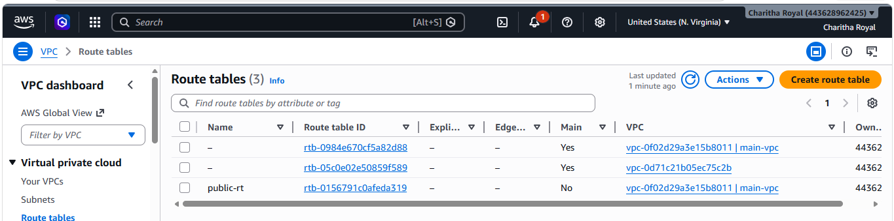
4) Create Subnet
Created a subnet within the VPC using the CIDR block 10.0.1.0/24 to host AWS resources.
Subnet creation using Terraform.
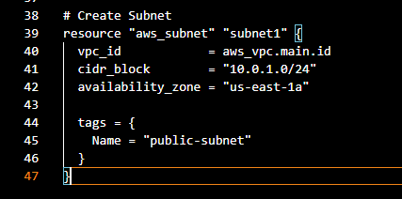
Commands executed terraform fmt, terraform validate, terraform plan, terraform apply
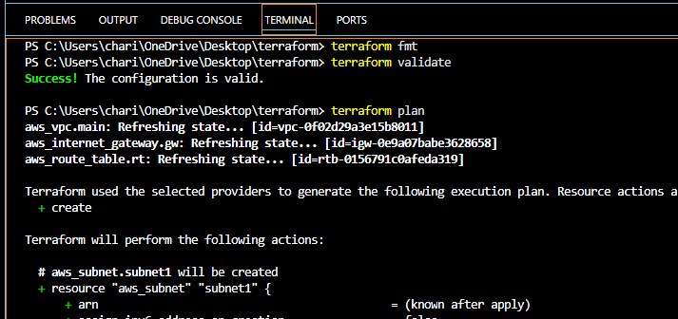
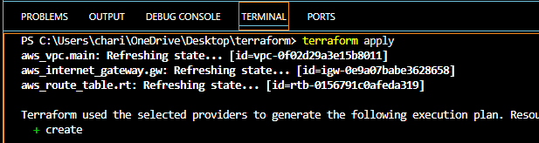
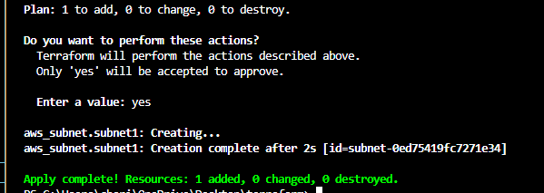
The subnet named public-subnet was successfully created
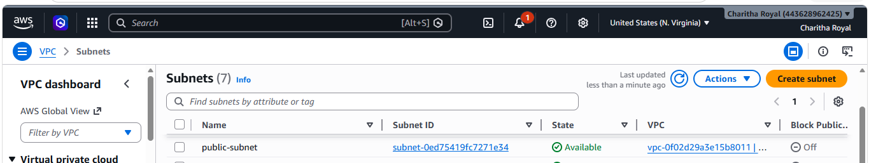
5) Associate subnet with Route Table
Associating the subnet with the route table to enable internet routing
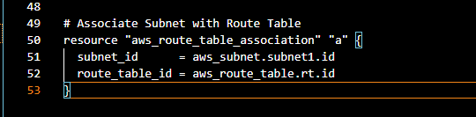
Commands executed terraform fmt, terraform validate, terraform plan, terraform apply
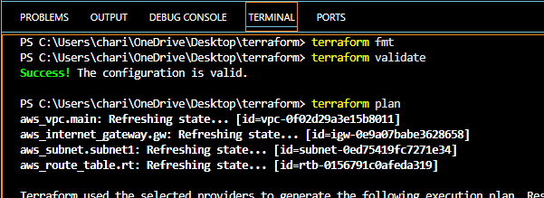
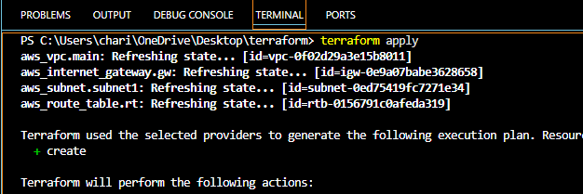
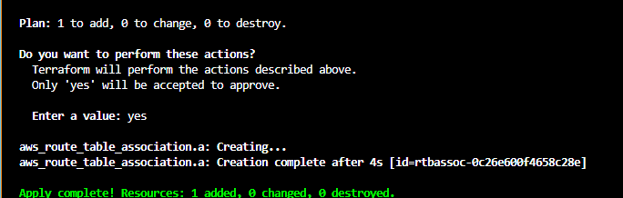
Associated the subnet with route table was successfully created
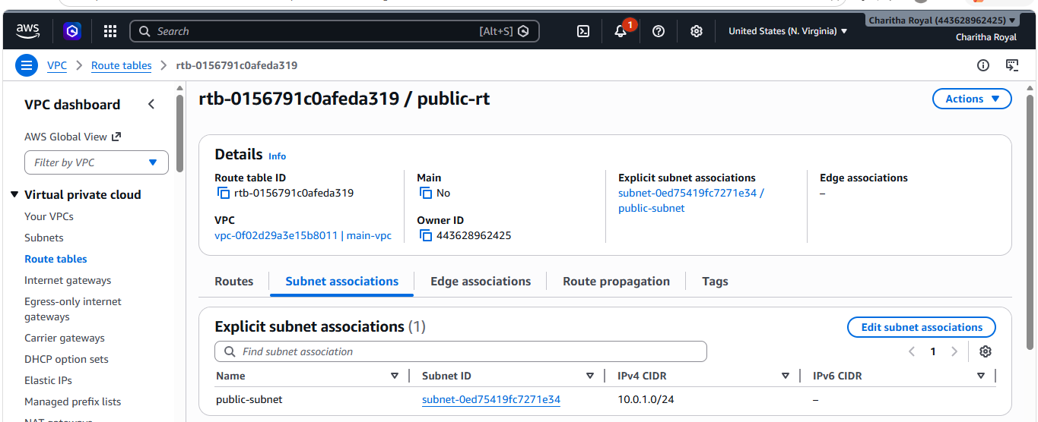
6) Create Security Group to allow port 22.80,443
Created a security group to allow inbound SSH (22), HTTP (80), and HTTPS (443) traffic and outbound access to all destinations.
Security Group creation using Terraform.
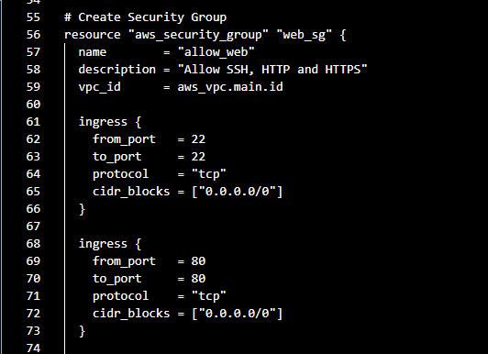
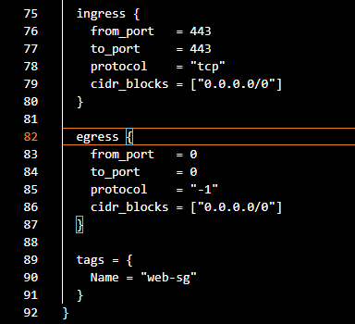
Commands executed terraform fmt, terraform validate, terraform plan, terraform apply
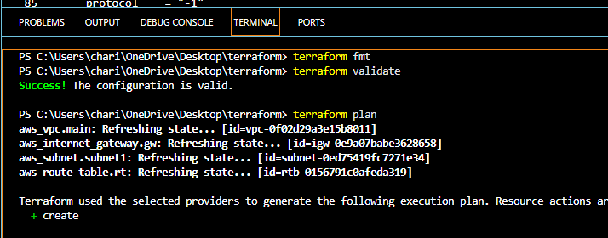
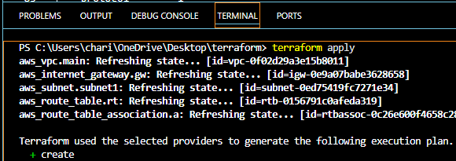
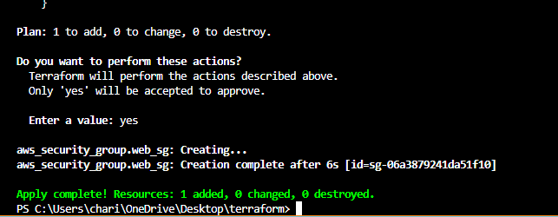
The security group web-sg was successfully created
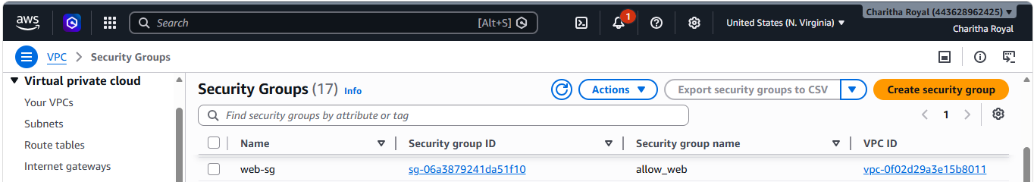
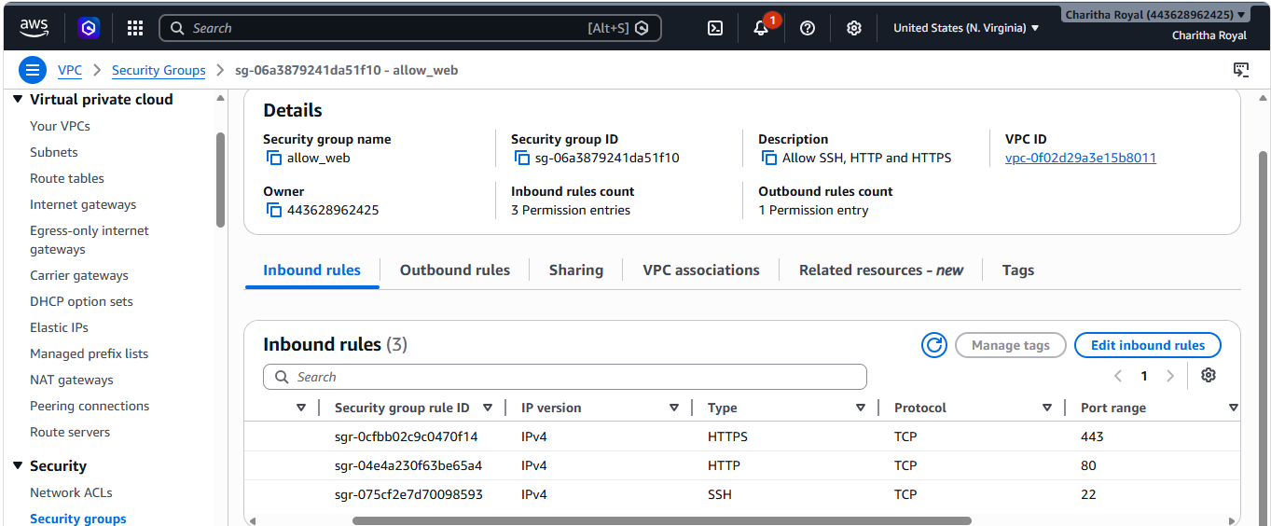
7) Create a network interface with an Ip in the subnet that was created in step 4
Created a network interface in the subnet and assigned the private IP address 10.0.1.50 with the security group attached.
Network Interface creation using Terraform.
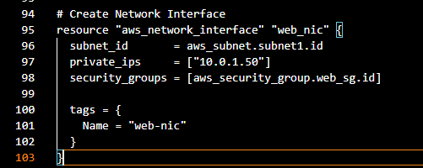
Commands executed terraform fmt, terraform validate, terraform plan, terraform apply
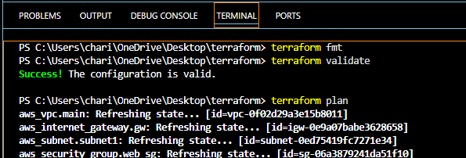
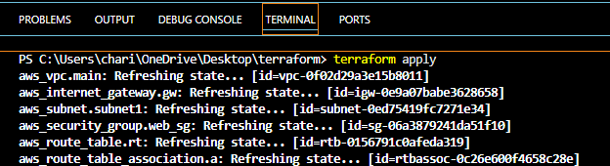
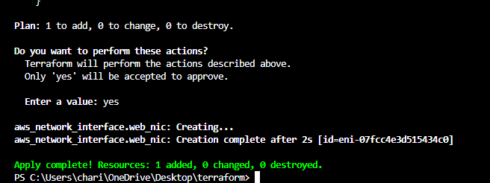
The network interface web-nic was successfully created in the public subnet with the specified private IP address and is ready to be attached to the EC2 instance.
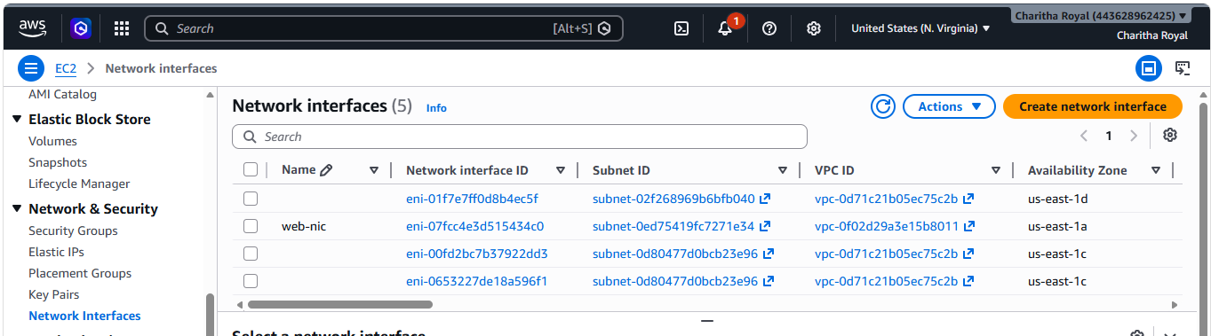

8) Assign an elastic IP to the network interface created in step 7
Allocated and associated an Elastic IP with the network interface to provide a static public IP address.
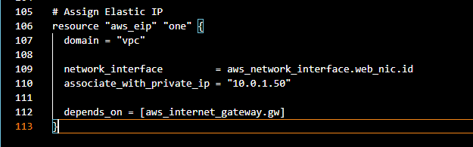
Commands executed terraform fmt, terraform validate, terraform plan, terraform apply
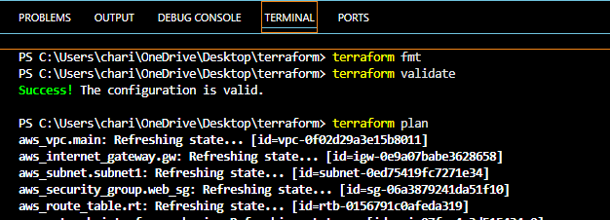
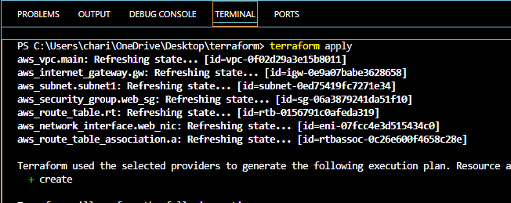
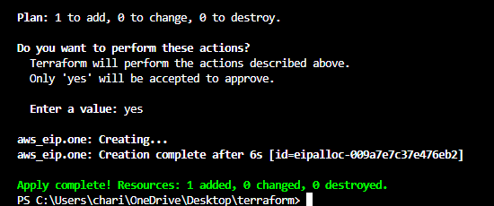
The Elastic IP was successfully created and is available for public access to the EC2 instance.
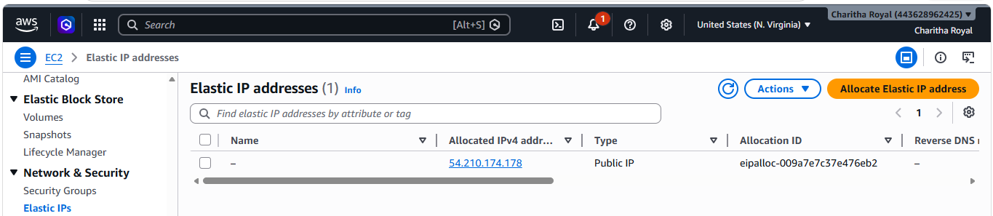

9) Create Ubuntu server and install/enable apache2
Terraform code for Ubuntu EC2 instance creation and Apache2 installation.
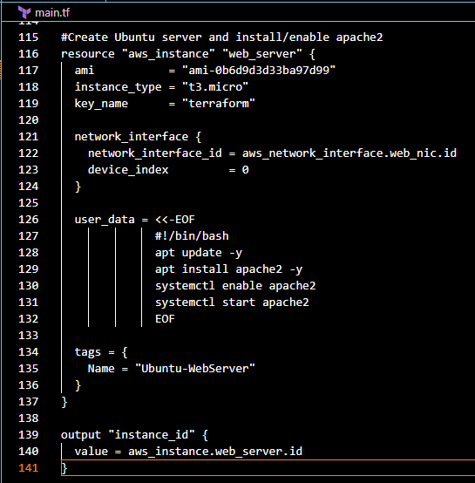
Commands executed terraform fmt, terraform validate, terraform plan, terraform apply
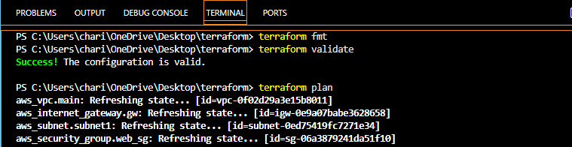
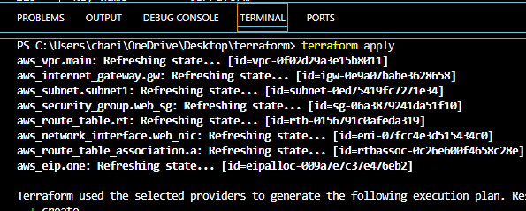
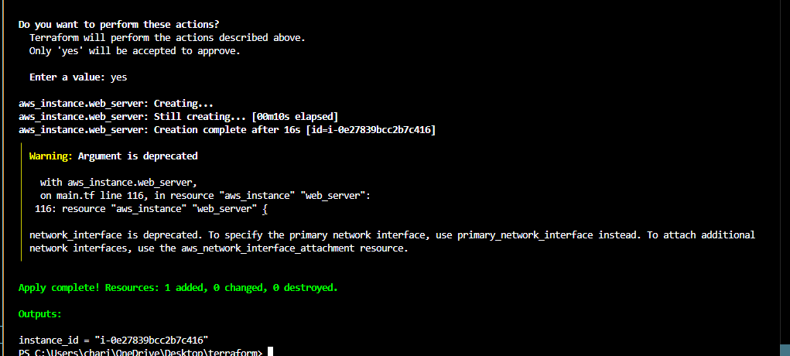
The Ubuntu EC2 instance was launched successfully, and Apache2 was installed and configured to serve web content.
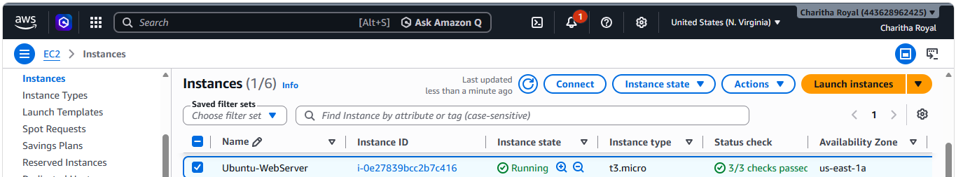
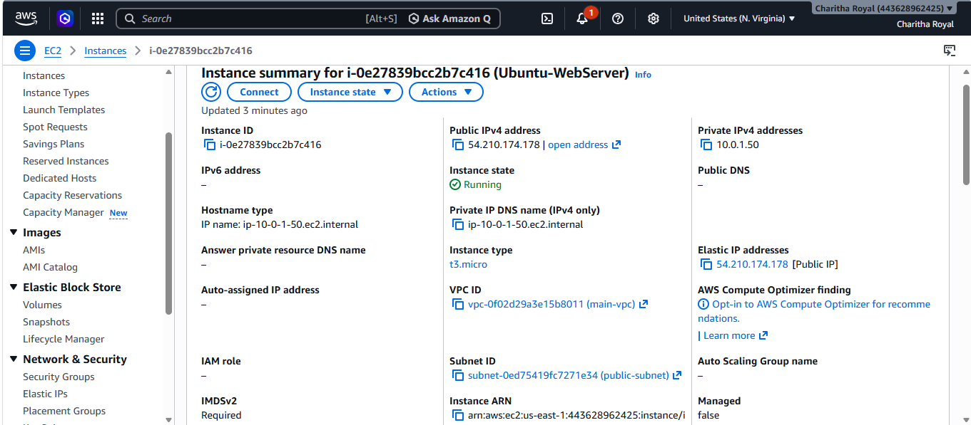
Apache2 web server accessed successfully through the Elastic IP address.
